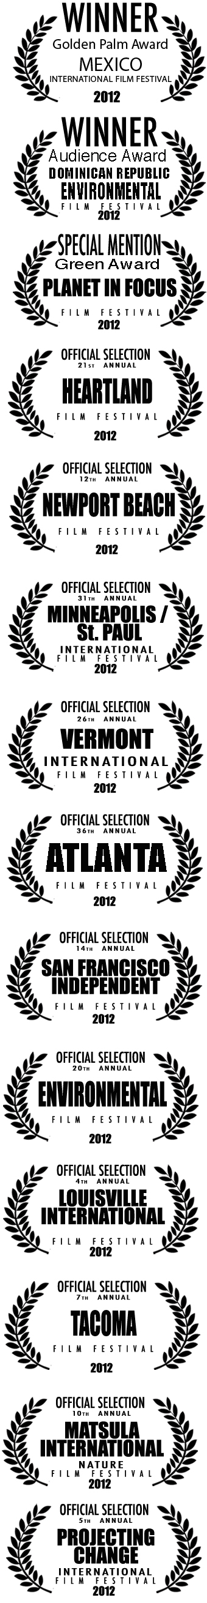
Documentary Movie Screening

Please join us on (date, time) for a local screening of
IN ORGANIC WE TRUST, a food systems solution movie.

*NOTE: REPLACE TEXT IN RED WITH RELEVANT INFO
DATE: TBD
SCREENING TIMES: TBD
LOCATIONS: VENUE INFORMATION AND ADDRESS
FOR MORE INFO CONTACT: LOCAL ORGANIZER CONTACT
ADMISSION: COST OR MENTION IF FREE

Watch the trailer here www.InOrganicWeTrust.org.

ABOUT: 78% of Americans eat some organic food because they think it’s healthier. But is it the solution we’ve been looking for? IN ORGANIC WE TRUST explores organic and its shortcomings. When corporations went into the business and “organic” became a brand, the philosophy and the label grew apart.

But there’s hope for organic and for us! Director Kip Pastor looks beyond the label and unearths inspiring solutions to our health and environment. Individual citizens and communities are taking matters into their own hands, and change is coming from the soil up.

WATCH. TALK. IMPACT.

“A Jaunty first-person tour”
-The Washington Post

“A LESSON WORTH REPEATING”
-Smells like Screen Spirit

“Puts the power in the hands of the individual”
-Daily Californian

“A relevant and revelatory documentary”
–Orange County Register

“CALLS INTO QUESTION CORPORATE INFLUENCE IN ORGANIC FOOD”
– San Francisco Chronicle

